Android Assignment

**a. What is Android? Who created it? What are Android Apps?**

* Android is a mobile operating system based on a modified version of the Linux kernel and other open source software, designed primarily for touchscreen mobile devices such as smartphones and tablets.
* Android is developed by a consortium of developers known as the Open Handset Alliance, with the main contributor and commercial marketer being Google. Initially developed by Android Inc., which Google bought in 2005, Android was unveiled in 2007, with the first commercial Android device launched in September 2008. The current stable version is Android 10, released on September 3, 2019.
* Android is an App based Operating system. An Android app is a software application running on the Android platform. Because the Android platform is built for mobile devices, a typical Android app is designed for a smartphone or a tablet PC running on the Android OS

**b. What is the software used in the development of Android Apps?**

The Android software development kit (SDK) includes a comprehensive set of development tools. Android Studio is the official[ integrated development environment (IDE) for Google's Android operating system, built on JetBrains' IntelliJ IDEA software and designed specifically for Android development.

**c. Which are the languages commonly used in the development of android apps? Which**

**language does InstiApp use?**

Android apps can be written using Kotlin, Java, and C++ languages.

InstiApp uses Java for developing the Android App. At the backend, it uses Python, Django.

**d. What is the activity cycle of a basic Android application? Diagrams/flowcharts**

**preferred.**

An activity is the single screen in android. It is like window or frame of Java.

Android Activity Lifecycle is controlled by 7 methods of android.app.Activity class. The android Activity is the subclass of ContextThemeWrapper class.

The Activity class provides a number of callbacks that allow the activity to know that a state has changed: that the system is creating, stopping, or resuming an activity, or destroying the process in which the activity resides.

The 7 callback methods are:

1. onCreate()
2. onStart()
3. onResume()
4. onPause()
5. onStop()
6. onRestart()
7. onDestroy()

Following flowchart helps in understanding how these work:

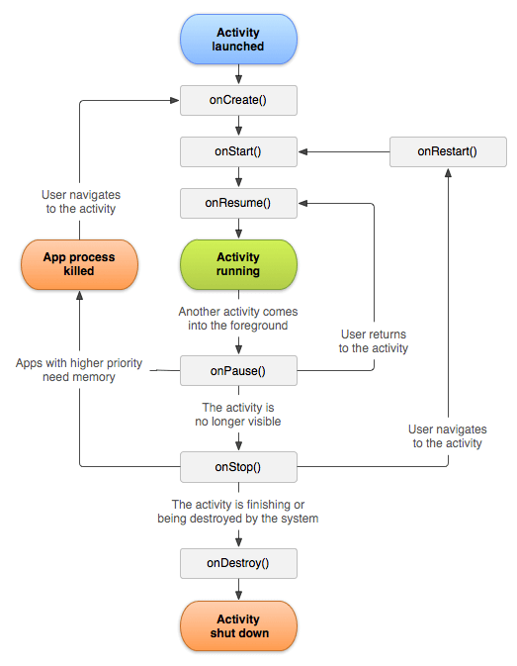

A few states the app goes through:

When you open the app:

onCreate() –> onStart() –> onResume()

If a phone is ringing:

onPause() –> onResume()

And so on

**e. What are 5 different UI elements in an android app? One example is a “TextView”.**

There are various UI elements such as:

* [TextView](https://www.tutlane.com/tutorial/android/android-textview-with-examples)
* [EditText](https://www.tutlane.com/tutorial/android/android-edittext-with-examples)
* [AutoCompleteTextView](https://www.tutlane.com/tutorial/android/android-autocompletetextview-with-examples)
* [Button](https://www.tutlane.com/tutorial/android/android-button-with-examples)
* [ImageButton](https://www.tutlane.com/tutorial/android/android-imagebutton-with-examples)
* [ToggleButton](https://www.tutlane.com/tutorial/android/android-toggle-button-with-examples)
* [CheckBox](https://www.tutlane.com/tutorial/android/android-checkbox-with-examples)
* [RadioButton](https://www.tutlane.com/tutorial/android/android-radiobutton-with-examples)
* [RadioGroup](https://www.tutlane.com/tutorial/android/android-radiogroup-with-examples)
* [ProgressBar](https://www.tutlane.com/tutorial/android/android-progressbar-with-examples)
* [Spinner](https://www.tutlane.com/tutorial/android/android-spinner-dropdown-list-with-examples)
* [TimePicker](https://www.tutlane.com/tutorial/android/android-timepicker-with-examples)
* [DatePicker](https://www.tutlane.com/tutorial/android/android-datepicker-with-examples)

And more...

Broadly they comprise the outlook of text, buttons, lists, access bars, etc.

**f. [BONUS]What are some of the salient features of those languages (part c)? How similar**

**are they to C++?**

**App Prototype**:

EditText

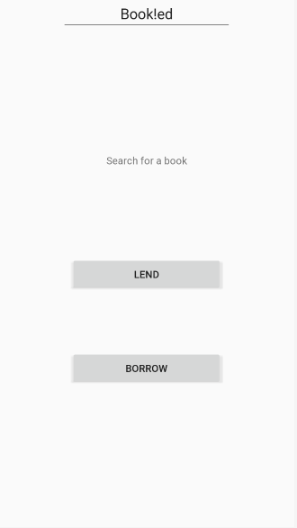

Button

Button

TextView

This is made using Relative Layout (Constrained Layout can also be used)

Has 3 basic UI elements